Experiment No. | 6
Aim | Graph Algorithm - Single source shortest path algorithm.Dijkstra Algorithms
Name | Sakshi D Lonare
UID No. | 2021300069
Class & Division | Comps SE A

Algorithm:-

- function dijkstra(G, S)
for each vertex V in G
distance[V] <- infinite
previous[V] <- NULL
If V != S, add V to Priority Queue Q
distance[S] <- 0

while Q IS NOT EMPTY
U <- Extract MIN from Q
for each unvisited neighbour V of U
tempDistance <- distance[U] + edge_weight(U, V)
if tempDistance < distance[V]
distance[V] <- tempDistance
previous[V] <- U
return dist[], pred[].

Program:-
#include <stdio.h>
#define MAX 10

void djk(int G[10][10],int n,int start)
{
int c[10][10],pred[10],dist[10];
int mindist, visited[10], count,nnode;
for(int i=0;i<n;i++)
{
for(int j=0;j<n;j++)
{
if(G[i][j]==0)
{c[i][j]=999;}
else
{
c[i][j]=G[i][j];
}
}
}
for(int i=0;i<n;i++)
{
dist[i]=c[start][i];
pred[i]=start;
visited[i]=0;

}
dist[start]=0;
visited[start]=1;
count=1;
while(count < n-1){
mindist=999;
for(int i=0;i < n;i++)
if(dist[i] < mindist&&!visited[i])
{
mindist=dist[i];
nnode=i;
}
visited[nnode]=1;
for(int i=0;i < n;i++)
if(!visited[i])
if(mindist+c[nnode][i] < dist[i])
{
dist[i]=mindist+c[nnode][i];
pred[i]=nnode;
}
count++;
}

for(int i=0;i < n;i++)
if(i!=start)
{
printf("\nDistance of %d = %d", i, dist[i]);
printf("\nPath = %d\n", i);
int j=i;
do
{
j=pred[j];
printf(" <-%d", j);
}
while(j!=start);
}
}

void main()
{
int G[10][10],i,j,n,s;
printf("Enter the no of vertices: \n");
scanf("%d",&n);
printf("\nEnter the adjacency matrix: \n");
for(i=0;i<n;i++)
{
printf("Vertex %d:",i+1);
for(j=0;j<n;j++){
scanf("%d",&G[i][j]);}
}
printf("\nEnter the starting vertex:\n");
scanf("%d",&s);
djk(G,n,s);

}

Output:-
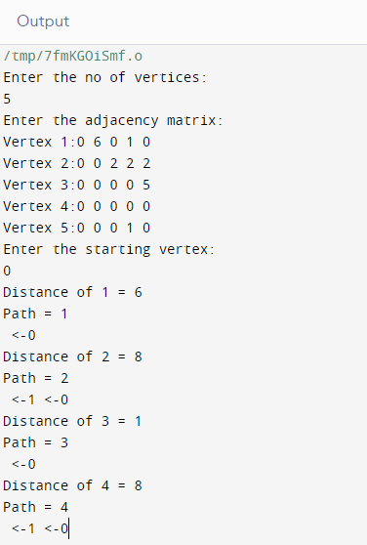

Conclusion: Learnt the algorithm that is Dijkstra Alogrithm . Dijkstra's algorithm is a very efficient algorithm for finding the shortest path between nodes in a graph. It makes use of the adjacency matrix to store the path costs. The algorithm has a time complexity of O((E+V) log V) .

